CS 148 Database Design for the Web

Jason Sheehan

Final Project

Pokemon Trainer

Version <1.0>

|  |  |  |  |
| --- | --- | --- | --- |
| Time Log | | | |
| Date | Time Spent (in hours) | Description | Author |
| 10/7/13 | 3.0 | First Version of Software Requirements | Robert Erickson |
|  |  | Your estimated time to complete assignment ____40_____ hours |  |
| 11/7/13 | 0.5 | Data Dictionary | Jason Sheehan |
| 11/7/13 | 0.5 | E-R Diagram | Jason Sheehan |
| 11/7/13 | 0.5 | Schema | Jason Sheehan |
| 11/7/13 | 0.5 | Story Board | Jason Sheehan |
| 11/7/13 | 0.5 | Finish Project Specifications | Jason Sheehan |
|  |  |  | Jason Sheehan |
|  |  |  | Jason Sheehan |
|  |  |  | Jason Sheehan |
|  |  |  | Jason Sheehan |
|  |  |  | Jason Sheehan |
|  |  |  | Jason Sheehan |
|  |  |  | Jason Sheehan |
|  |  |  | Jason Sheehan |
|  |  |  | Jason Sheehan |
|  |  |  | Jason Sheehan |
|  |  |  | Jason Sheehan |
|  |  |  | Jason Sheehan |
|  |  |  | Jason Sheehan |
|  |  |  |  |
|  |  |  |  |
|  |  |  |  |
|  |  |  |  |
|  |  |  |  |
|  |  |  |  |
|  |  |  |  |
|  |  |  |  |
|  |  |  |  |

Table Of Contents

Software Requirements Specifications 4

Introduction 4

Purpose 4

Definitions, acronyms, and abbreviations 4

Overview 4

Overall Description 5

Data Dictionary 6

E-R Diagram 7

Schema 8

Story Board 9

Specific requirements 10

# Software Requirements Specifications

## Introduction

### Purpose

The purpose of this document is to describe the requirement specification for the web site “Pokemon Trainer”.

The intended audience for this document is the prospective developers of this site. The goal being that you can give this document to someone and they can make the site without having to ask any questions.

### Definitions, acronyms, and abbreviations

HTML – Hypertext markup language – used to define your conent.

PHP – Personal Home Page – language that helps to customize html.

CSS – Cascading Style Sheets – used to define the look of a web site.

W3 Validation – refers to both Html and CSS validation tool provided by the W3c.org. the html validator is located at:

<http://validator.w3.org/>

with the CSS validator located at:

<http://jigsaw.w3.org/css-validator/>

### Overview

The rest of this document contains an overall description of the Pokemon Trainer web site.

## Overall Description

My site is going make you register and login in order to view the full site. When you register you will fill out information about you and what pokemon you want to have. There will be a page to display everyones information and chosen pokemon. There will also be a page that gets information from the data base and displays certain "gym leaders". The stretch goal for this project which may or may not be met is to implement a sort of RNG (Random Number Generator) battle system.

### Data Dictionary

### 

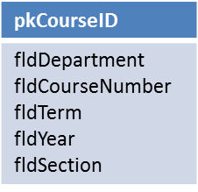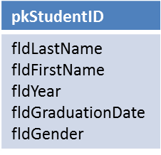

Student

Courses

### E-R Diagram

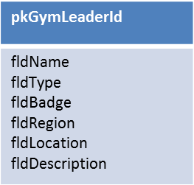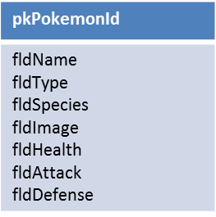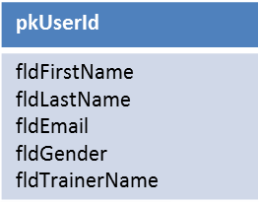

Gym Leaders

has

Pokemon

### 

### Schema

CREATE TABLE tblPokemon(

pkPokemonId int(4) PRIMARY KEY NOT NULL AUTO_INCREMENT,

fldType varchar(20),

fldSpecies varchar(20),

fldImage varchar(25),

fldHealth int(5),

fldAttack int(5),

fldDefense int(5)

)

ENGINE=MyISAM DEFAULT CHARSET=utf8 AUTO_INCREMENT=1;

CREATE TABLE tblUser(

pkUserId int(4) PRIMARY KEY NOT NULL AUTO_INCREMENT,

fldFirstName varchar(20),

fldLastName varchar(20),

fldEmail varchar(35),

fldGender varchar(10),

fldTrainerName varchar(25),

fkPokemonId int(4) not null references tblPokemon(pkPokemonId)

)

ENGINE=MyISAM DEFAULT CHARSET=utf8 AUTO_INCREMENT=1;

CREATE TABLE tblGymLeaders(

pkGymLeaderId int(4) PRIMARY KEY NOT NULL AUTO_INCREMENT,

fldType varchar(20),

fldBadge varchar(20),

fldRegion varchar(25),

fldLocation varchar(25),

fldDescription TEXT,

fldIamge varchar(25)

)

ENGINE=MyISAM DEFAULT CHARSET=utf8 AUTO_INCREMENT=1;

### Story Board

PostLoginHome.php

gymLeaders.php

Login.php

Trainers.php

Register.php

PreLoginHome.php

## Specific requirements

Here is just a list of things I will require you really need to write the specific requirements as they relate to your project.

1. *Location* – all files will be located in the public folder of your uvm account. The assignment web page and the submit process will detail the exact location. Failure to have your site located in the correct folder by the due dates will result in a zero on the assignment. Be sure to pay attention to the lowercase letters.
2. *Html Validation* – All pages will pass W3C Html validation for html 5.
3. *CSS Validation* – All pages will pass W3C 3.0 CSS validation.
4. *Meta Information* – All pages will contain a proper title tag, Meta tags (author, character set and description).
5. *CSS* – all pages will have a linked style sheet.
6. *Navigation* – All pages will contain navigation to all other pages on the site using an ordered list. Be sure to enclose the navigation in the correct element.
7. *Content* – Each page will have a minimum of 150 words not counting titles, lists or links. Be sure to use the correct elements to hold your content.
8. *Browser compatibility* - This site will be checked on Firefox, Safari, Chrome and Internet Explorer.
9. *File Names* – the main home page will be called home.php with the rest of the file names up to you (be sure to use .php, .css for the respective files).
10. *The register*.php page will submit to itself and update/insert records into the database.
11. *The trainers*.php page will display everyone's information pertaining to the information they have entered upon registration.
12. *The gymleaders*.php page will display the gym leaders and their information from the database.